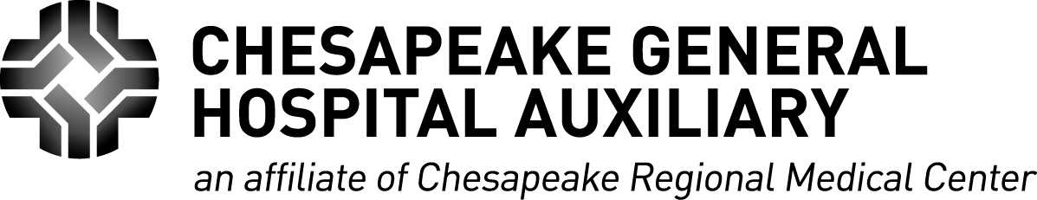

On behalf of the Chesapeake General Hospital Auxiliary, I would like to thank you for your interest in Chesapeake Regional Medical Center. Our purpose is to assist the hospital with service projects that promote the health and welfare of our community. We invite you to join us in our efforts by becoming a member of the Auxiliary.

The Auxiliary sponsors several fundraisers, including quarterly vendor sales in the lobby, the “Light the World” Christmas fundraiser, and the ‘Peake Boutique gift shop, operated by the Auxiliary and staffed by volunteers. Proceeds from these service projects, and others, help to purchase necessary state-of-the-art medical equipment and fund scholarships for deserving Chesapeake high school students entering the medical profession.

We host quarterly general membership meetings and an annual banquet in June. In addition to providing excellent food, these meetings are informative and enjoyable.

I hope you will support our community hospital and become a member today!

Sincerely,

Carol

Carol Mosman

Membership Chair

603-960-0259

**MEMBERSHIP FORM 2024-2025**

____ Yes, I would like to renew my membership or become a new member of the Chesapeake General Hospital

Auxiliary. Enclosed is $10 for annual dues.

____ Yes, I would like to become a “Lifetime Member.” Enclosed is $100.

Name:

Address:

Email:

Phone: Home: Cell:

Would you like to help with one or more of the following hospital fundraisers?

_____ Quarterly Sales _____ Light the World _____ Gift Shop _____ Other

*Please make check payable to: Chesapeake General Hospital Auxiliary*

*Mail to: Carol Mosman, 805 Nicholson Ct., Chesapeake, VA 23320*