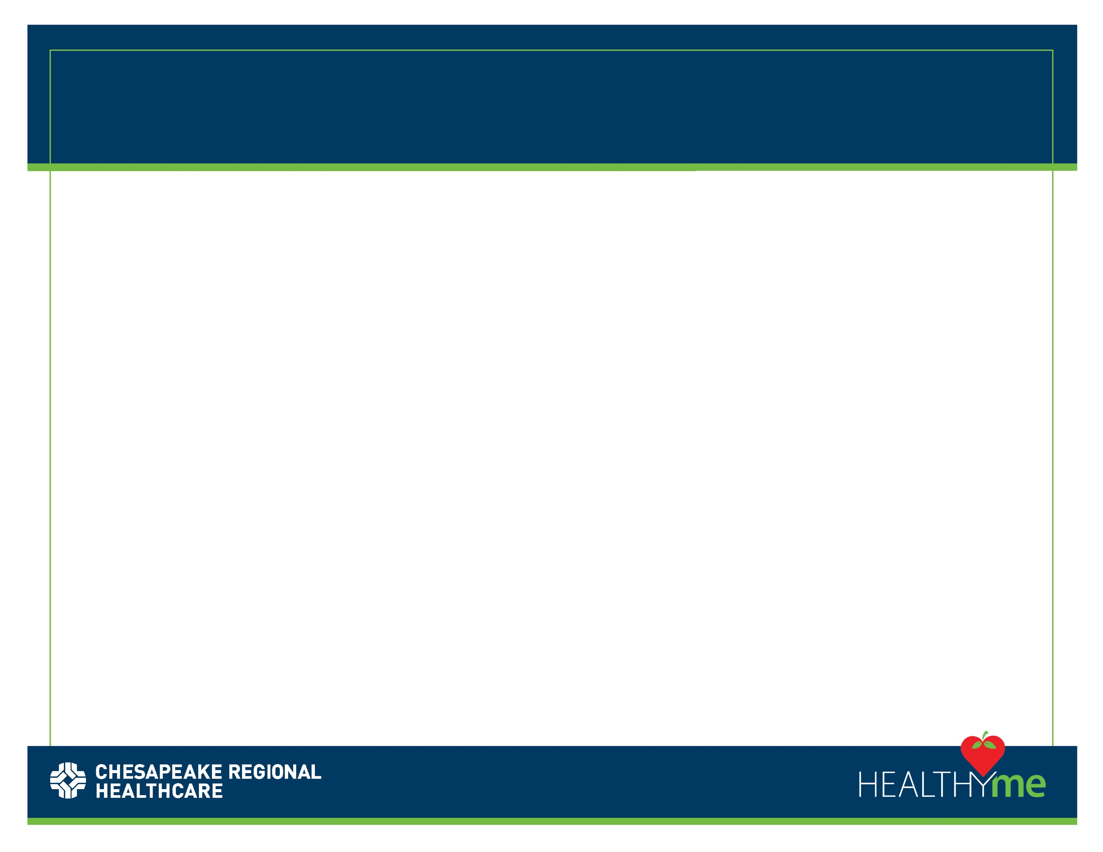

Body Copy, Content, Information,

Photos, etc.

Here

**HEADLINE HERE**